Final Report
NUTRITIONAL BIOINFORMATICS & HUMAN METABOLISM

1. Introduction
Nutrition provides the essential substances required for energy production, growth, tissue maintenance, and normal physiological functions. Nutrients can be broadly classified into macronutrients, including carbohydrates, proteins, and lipids, and micronutrients, including vitamins and minerals. Water is also essential for maintaining cellular and metabolic functions.
This project investigates the nutritional composition of selected foods and dietary supplements and examines the relationship between nutrients and human metabolism. Nutritional data were organized and analyzed using Microsoft Excel, while BioRender was used to present biological and metabolic concepts visually. The project demonstrates how computational tools can support the organization, analysis, and interpretation of nutritional information.

2. Objectives
The objectives of this project were to:
- Classify major nutrients and describe their biological roles.
- Analyze the nutritional composition of selected foods and supplements.
- Compare calories and major macronutrients using Excel.
- Examine the role of nutrients in human metabolic pathways.
- Present nutritional and biological information using charts and BioRender diagrams.

3. Nutrient Classification and Biological Roles
Nutrients are divided into macronutrients and micronutrients according to the amount required by the body. Carbohydrates are an important source of energy, while proteins provide amino acids required for tissue formation, enzymes, transport, and cellular functions. Lipids provide concentrated energy and are important components of cell membranes and signaling molecules.
Vitamins and minerals are required in smaller amounts but are essential for metabolism, enzyme activity, immunity, bone health, oxygen transport, and other physiological processes. Water supports digestion, nutrient transport, temperature regulation, cellular reactions, and removal of metabolic waste.
Figure 1. Classification of Major Nutrients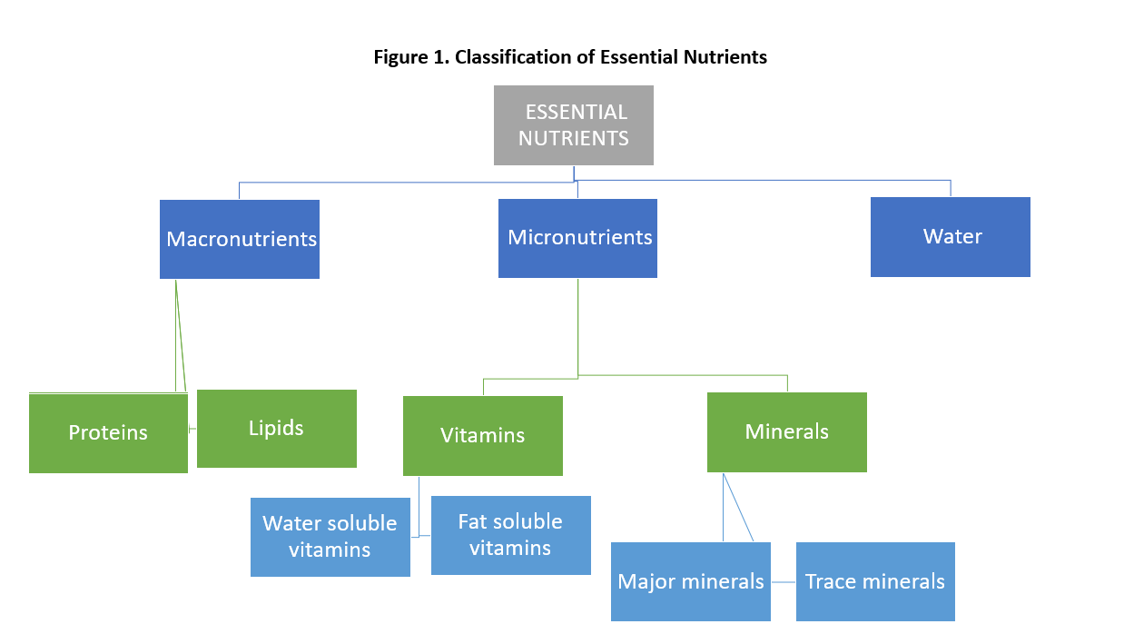
Figure 1 shows the classification of nutrients into macronutrients and micronutrients and highlights water as an essential component of human nutrition.

4. Food Composition and Nutritional Analysis
A nutritional database containing selected food items was prepared using information obtained from reliable nutritional sources. The dataset included values such as calories, protein, carbohydrates, and fats. Microsoft Excel was used to organize the data and compare the nutritional composition of the selected foods.
The analysis showed variation in both energy content and macronutrient composition. These differences demonstrate that foods can contribute differently to daily energy and nutrient intake.
Figure 2. Food Nutritional Composition
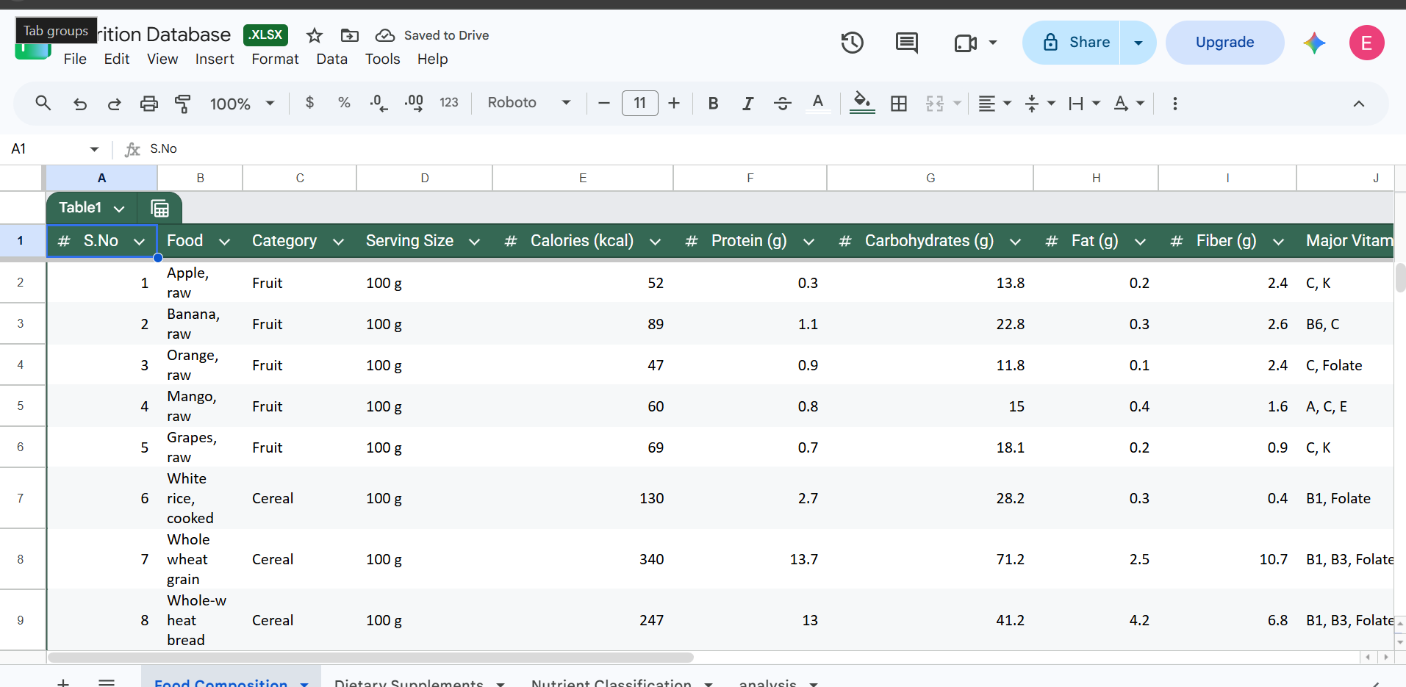The database provided a structured collection of nutritional information that could be used for comparison and further analysis.
Figure 3. Calorie Analysis of Selected Foods
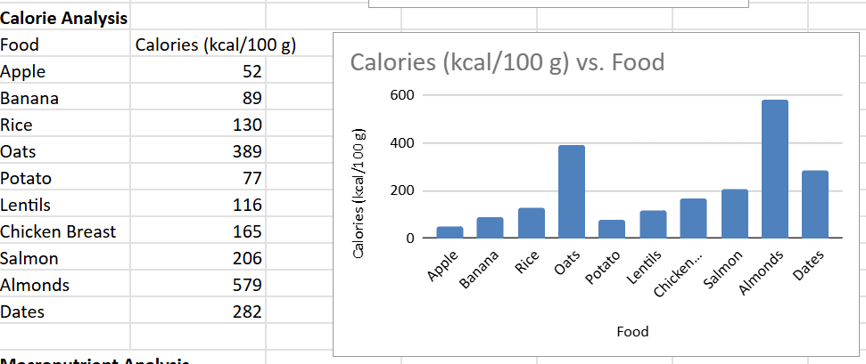Figure 3 shows the differences in calorie content among the selected foods. Foods with higher calorie values provide greater amounts of dietary energy per the specified serving or quantity used in the dataset.

5. Dietary Supplements
Selected dietary supplements were also reviewed according to their nutrient composition and common nutritional roles. Supplements may provide concentrated sources of vitamins, minerals, amino acids, fatty acids, or other nutrients.
The analysis showed that supplements differ considerably in their composition and intended nutritional purpose. They are best considered as complementary sources of nutrients rather than replacements for a balanced diet.

6. Human Metabolism and Metabolic Pathways
Human metabolism consists of interconnected biochemical reactions through which nutrients are converted into energy and other molecules required by cells. Carbohydrates can be broken down into glucose, which enters glycolysis and other energy-producing pathways. Lipids can be broken down into fatty acids and used as an energy source, while proteins provide amino acids for protein synthesis and other metabolic reactions.
Figure 5. Nutrient Metabolism and Metabolic Pathways
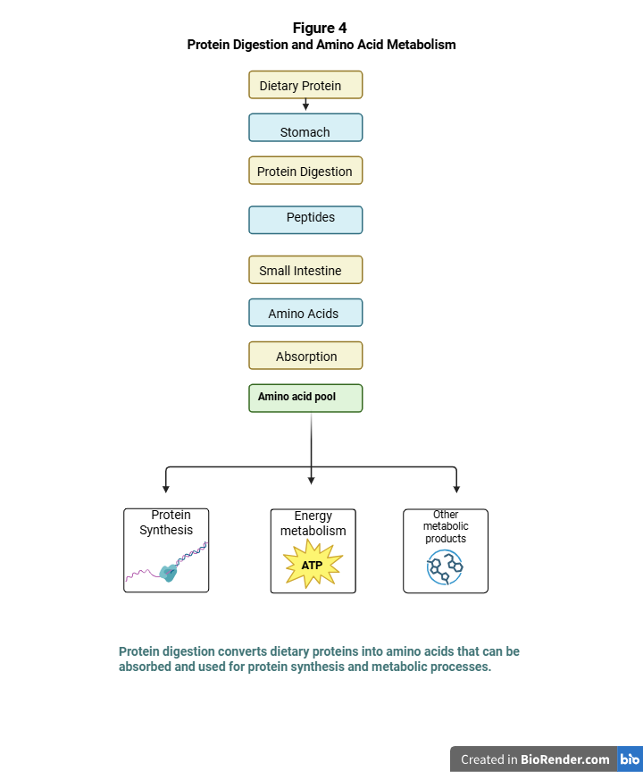

7. Computational and Visualization Approach
Microsoft Excel was used to organize the nutritional dataset, compare nutrient values, and generate graphical representations. BioRender was used to create biological diagrams and illustrate metabolic relationships. Scientific and nutritional databases were used to obtain supporting information.
This combination of data organization, basic computational analysis, and biological visualization provided a clear approach for interpreting nutritional information.

8. Results and Discussion
The analysis demonstrated that the selected foods differed in their calorie and macronutrient composition. The Excel-based analysis made these differences easier to compare through tables and graphical representations. The metabolic analysis further showed that carbohydrates, proteins, and lipids are interconnected through biochemical pathways that support energy production and cellular activities.
The project also demonstrated the usefulness of computational tools in nutritional bioinformatics. Organizing nutritional information into a structured database makes it easier to compare food components, identify patterns, and present biological information in an understandable form.
The highest-calorie food was olive oil (884 kcal/100 g), while roasted chicken breast had the highest protein content (31 g/100 g). Dried dates contained the highest carbohydrate content (75 g/100 g), whereas olive oil had the highest fat content (100 g/100 g).

9. Conclusion
This project provided an integrated overview of nutrition, food composition, and human metabolism. Major nutrients were classified according to their biological roles, while selected foods and supplements were analyzed using structured nutritional data. Excel supported data organization and graphical analysis, whereas BioRender helped visualize biological and metabolic relationships.
Overall, the project demonstrated how bioinformatics and computational tools can be applied to organize, analyze, and communicate nutritional and biological information effectively.

10. References
Food and Agriculture Organization of the United Nations. (n.d.). Food composition. https://www.fao.org/food-composition/en/
U.S. Department of Agriculture, Agricultural Research Service. (n.d.). FoodData Central. https://fdc.nal.usda.gov/
World Health Organization. (2026, January 26). Healthy diet. https://www.who.int/news-room/fact-sheets/detail/healthy-diet
World Health Organization. (2024, March 1). Malnutrition. https://www.who.int/news-room/fact-sheets/detail/malnutrition
World Health Organization, & Food and Agriculture Organization of the United Nations. (2024, October 24). What are healthy diets? Joint statement by the Food and Agriculture Organization of the United Nations and the World Health Organization. https://www.who.int/publications/i/item/9789240101876
World Health Organization. (2024, January 24). Trans fat. https://www.who.int/news-room/fact-sheets/detail/trans-fat

